Methodology

**Amplifier part**

when there is an object with a temperature different than ambient temperature, is moving in front of the PIR sensor which emits a small Ac signal around 1 mVpp. as our task to detect the human motion, we need to consider the frequencies from 0.5 Hz to 10 Hz. further more that signal will be around a DC level which is significant sensor to sensors.

therefore, it is mandatory to cancel out the DC part of the signal then the AC part of the signal should be amplified. As the signal has the environment effect, Nosie filtering will be useful as well. the Op amps are very helpful to achieve for all these functions. we can divide the amplifier part into four sub parts.

**stage 01**

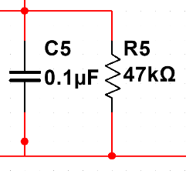

*from the PIR sensor*

*to the op amp 1*

At the first PIR sensor’s signal will go through the C5, R5 (first order filter). here we can see that it will act like an LPF (Low Pass Filter). therefore, there will be an upper cut off frequency which can be calculated as below.

$$f_{upper cut off}=\frac{1}{2πR_{5}C_{5}}=\frac{1}{2π×47 kΩ ×0.1 μF}≈34 Hz$$

As we have already known that our final task is to detect the human motion which is around 10 Hz such that it’s approximately taken the 34 Hz as the upper cut off which is not harm. Other than that, we can simply avoid the high frequency noises (not thoroughly) as well as the environmental effects at this simple stage.

**stage 02**

After that our signal will enter in to the next stage where we can cancel out the DC component by a capacitor. the smoothing circuit will get rid of the high frequency noise as well as, give the variable gain to accommodate the sensitivity at a certain level.

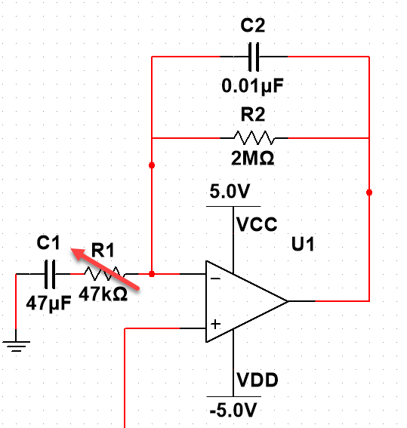

*from the LPF part*

*to the op amp 2*

as it’s explained above, C1 will cancel out the DC components from the sensor and allows the AC components of the signal. the value of the capacitor is taken same as the C5 in previous discussion without any particular reasoning. there will be a lower cut off value for the smoothing filter which can be calculated as shown below.

$$f_{lower cut off}=\frac{1}{2πR_{2}C_{2}}=\frac{1}{2π×2 MΩ ×0.01 μF}≈8 Hz$$

According to the bode plot of the integrator circuit of the op amp, amplitude will be decreasing and smoothing will be started at the lower cut off point. it is calculated that at around 8 Hz circuit starts the smoothing functionality as well as the amplitude of the output signal is high (our requirement is at 10Hz so, no issues). Furthermore, as it’s mentioned earlier the gain of the is first op amp can be adjustable as shown below.

$$A_{op1}=-\frac{R2}{R1}$$

it is possible to set this gain as constant if we don’t want the distance as a variable. Such that it is assumed to set the gain from the first op amp as ~40. furthermore, R2 can be easily got from the R5 value and R2

$$R_{5}=R_{1}\left|R_{2}=47 kΩ \right|2 MΩ≈47kΩ$$

but this value is only valid for the object which is moving nearby (< ~ 50cm) the PIR sensor. such that when it is increased to detect the object far from the previous value. therefore, the potentiometer value is selected as 1M ohm (quite reasonable). Furthermore, our input is an AC signal such that we have to supply a negative voltage to the op amp.

**stage 03**

After this part our signal again enter into a capacitor in order to avoid any DC components coming out from the op amp 1. Moreover, C3 is also chosen same as the previous discussion.

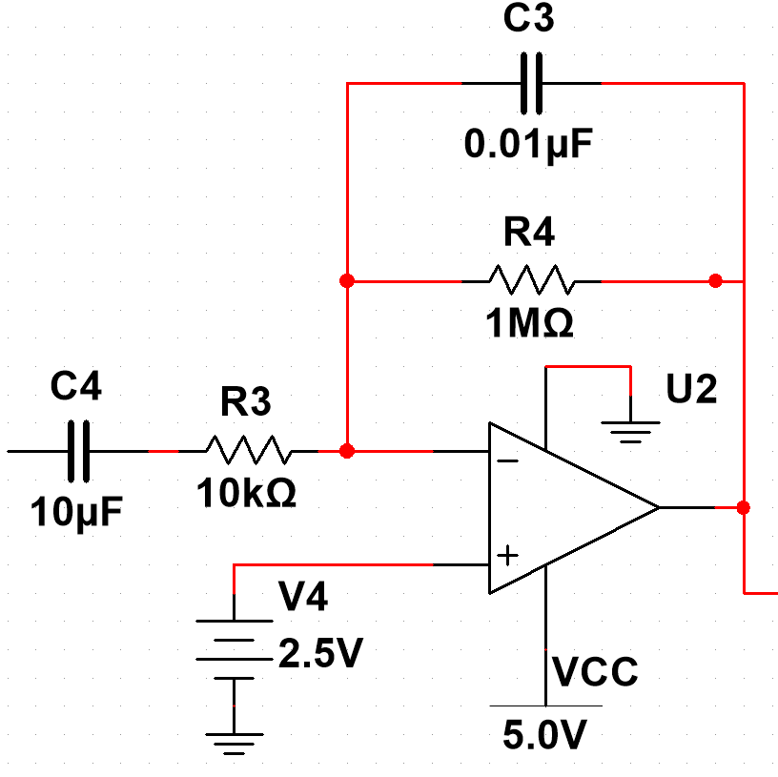

*from the op amp 1*

*to the window comparator*

In this circuit we can simply increase the gain by another amount. That can be calculated as below.

$$A_{op2}=-\frac{R_{4}}{R_{3}}=-\frac{1MΩ}{10kΩ}=-100$$

such that the total gain can be calculated by multiplying the two gain values. this is very important for the proper selection of R1 in the first op amp as well as maintaining the peak to peak amplitude of the signal at |2.5V| for the next stage.

The non-inverting voltage V4 is chosen to give the DC bias to the output signal from this part. this is useful when it comes to the window comparator. it’s efficient as well as good for the minimizing the error if we can utilize the VCC (5 V) as the peak to peak voltage such that whether the positive or negative part of the signal will be on the bias of VCC x 0.5 = 2.5V. That means our amplified signal will be on top of +2.5V bias voltage.

**stage 04**

Now we can look at the window comparator part.

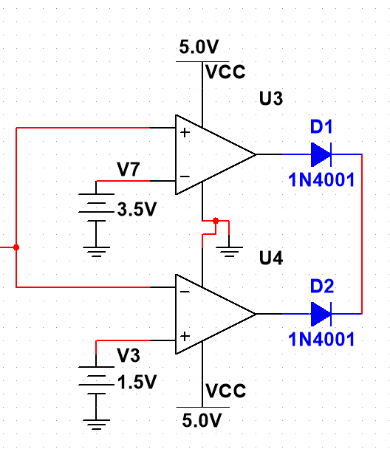

*from the op amp 2*

*to the next stage*

thresholding voltages are also selected to detect the signals at a perfect region as given below.

$$V_{7}=VCC ×0.7=5×0.7=3.5 V$$

$$V_{3}=VCC ×0.3=5×0.3=1.5 V$$

therefore, the voltages less than 1.5V or greater than 3.5V will inform as a motion. This is clearly explained in the given image.

After we add both signals by two diodes rather than connecting both signals directly to the next stage. because the diodes will stop the external voltage which is higher than the op amp’s output, enters into the op amp.

Here we are dealing with only the positive signal such that we don’t need to use negative supply to the window comparators.